Exercise 1: Control Structures

Scenario 1: The bank wants to apply a discount to loan interest rates for customers above 60 years old.
o Question: Write a PL/SQL block that loops through all customers, checks their age, and if they are above 60, apply a 1% discount to their current loan interest rates.
DECLARE
CURSOR c_customers IS SELECT CustomerID, DOB FROM Customers;
v_age NUMBER;
BEGIN
FOR r_cust IN c_customers LOOP
v_age := TRUNC(MONTHS_BETWEEN(SYSDATE, r_cust.DOB) / 12);
IF v_age > 60 THEN
UPDATE Loans
SET InterestRate = InterestRate - 1
WHERE CustomerID = r_cust.CustomerID;
END IF;
END LOOP;
COMMIT;
END;
/
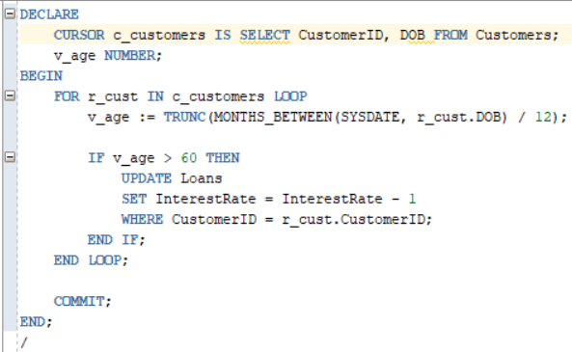
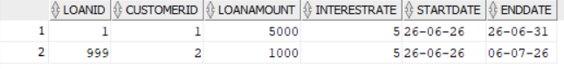
Scenario 2: A customer can be promoted to VIP status based on their balance.
o Question: Write a PL/SQL block that iterates through all customers and sets a flag IsVIP to TRUE for those with a balance over $10,000.

ALTER TABLE Customers ADD IsVIP VARCHAR2(5) DEFAULT 'FALSE';
DECLARE
CURSOR c_customers IS SELECT CustomerID, Balance FROM Customers;
BEGIN
FOR r_cust IN c_customers LOOP
IF r_cust.Balance > 10000 THEN
UPDATE Customers
SET IsVIP = 'TRUE'
WHERE CustomerID = r_cust.CustomerID;
END IF;
END LOOP;
COMMIT;
END;
/
SELECT * FROM Customers;
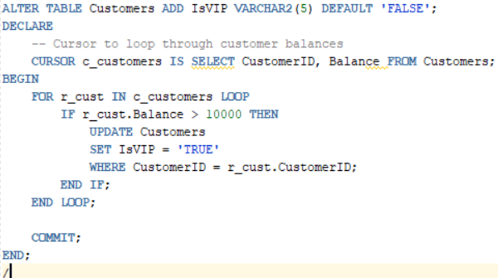

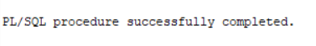
Scenario 1 & 2 Result:
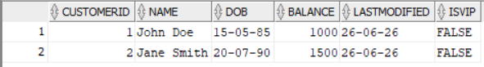

Scenario 3: The bank wants to send reminders to customers whose loans are due within the next 30 days.
o Question: Write a PL/SQL block that fetches all loans due in the next 30 days and prints a reminder message for each customer.
DECLARE
CURSOR c_due_loans IS
SELECT c.Name, l.LoanID, l.EndDate
FROM Customers c
JOIN Loans l ON c.CustomerID = l.CustomerID
WHERE l.EndDate BETWEEN SYSDATE AND SYSDATE + 30;
BEGIN
FOR r_loan IN c_due_loans LOOP
DBMS_OUTPUT.PUT_LINE('Reminder: Customer ' || r_loan.Name ||
', your loan (' || r_loan.LoanID ||
') is due on ' || TO_CHAR(r_loan.EndDate, 'YYYY-MM-DD'));
END LOOP;
END;
/
